LESSON THREE

BUILD A COHESIVE UNIT OR ORGANIZATION

Critical Task, 01.9001.17-0003

OVERVIEW

LESSON DESCRIPTION:

In this lesson you will review the fundamentals of cohesion and the concept of unit cohesion. You will learn how to determine the cohesiveness of an organization and how to use the factor areas of unit cohesion to improve the cohesion in your organization.

TERMINAL LEARNING OBJECTIVE:

ACTION: | You will develop a plan to build a cohesive unit or organization
CONDITIONS: | Given the subcourse material and a practice exercise.
STANDARDS: | Build a cohesive unit or organization by developing and executing a plan. As a minimum your plan must address:  1. Your assessment of the cohesiveness of the organization.  2. An explanation of how you will use the factors of unit cohesion to improve cohesion in your organization.
REFERENCES: | The material contained in this lesson was derived from the following publications: DA Pam 350-2, FM 22-100, FM 22-102, STP 21-II-MQS.
"The Army is a team. It eats, sleeps, breathes, fights, as a team."

GEN. George S. Patton

INTRODUCTION

General Patton knew the importance of cohesion in combat. The 20th Maine, under the command of Colonel Chamberlain, in the Battle of Gettysburg, demonstrated an exceptional degree of unit cohesion. Technology and improved tactics have increased the tempo and lethality of war, but cohesion is still the force that turns the tide of battle. As a future commander or staff officer, you are responsible for building a cohesive organization and much of your unit's success depends on how successful you are.

Cohesion is defined as the bonding together of soldiers and their leaders in such a way as to develop and sustain their commitment to the unit and their resolve to accomplish the mission. The three key elements of unit cohesion are: bonding, commitment, and resolve.

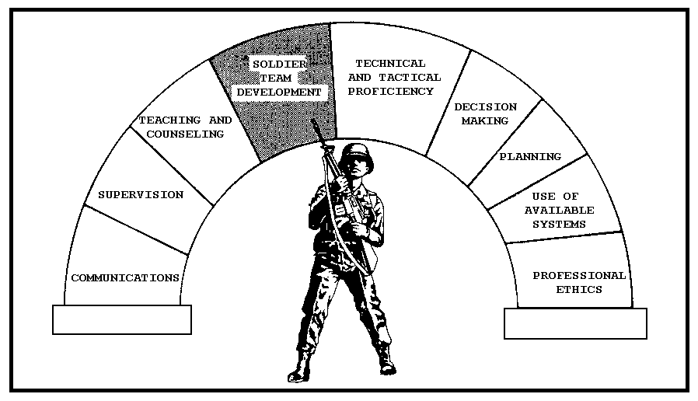

Figure 3-1, Leadership Competencies.

The leadership competency of soldier team development focuses on developing cohesive soldier teams that are the foundation of cohesive units and organizations.
PART A

THE FUNDAMENTALS OF UNIT COHESION

In this part of the lesson you will learn the fundamentals of unit cohesion, including: the concept of unit cohesion, the relationship of the stages of soldier team development to unit cohesion, and the factor areas of unit cohesion.

1. Unit cohesion.

a. We've all been in units when it really felt good to be part of the unit. Whether it was after a successful ARTEP, a strong performance at the National Training Center, a high gunnery score, or an inspection that went well, we've all had that feeling.

Have you ever experienced the opposite feeling, the feeling that you didn't want to be part of the unit? What effect did this have on you, the unit and the soldiers?

Whether your feelings about a unit are positive or negative, they are real. Good commanders create a set of positive conditions that result in both mission accomplishment and a positive feeling among the members of the unit. The better the job you do in creating these positive conditions, the more successful you will be as a commander. Cohesion and unit success generally go hand in hand.

Take the opportunity now to review an extract from your officer basic course (OBC) lesson addressing cohesion. It is located in Appendix A beginning on page A-3-1. The remainder of this lesson builds on that information.

b. As you prepare to take command of a company, you need to begin looking at soldier team development and cohesion from a larger perspective. Rather than focusing on the development of a cohesive platoon, as you have in the past, you are now responsible for bringing platoons and sections together to form a cohesive unit.

Is there a difference between cohesion at the platoon level and cohesion at company level? Yes, there is a difference. Platoon cohesion occurs when the members of a platoon achieve a bond based on mutual trust and respect, are committed to the platoon mission, and demonstrate resolve in their dedication to accomplish the platoon mission.

Company or unit cohesion also involves these three key elements; however, because of the size of the unit there is a difference.
At the company level cohesion is the result of mutual trust and respect between key company leaders and between platoons rather than between individuals. Commitment at the company level is commitment to the company mission and resolve is the determination to accomplish the company mission.

Platoon cohesion is an interpersonal relationship. Company cohesion is an interorganizational relationship that cannot exist without cohesive platoons. Cohesive platoons are the foundation of cohesive companies. Tough, challenging training that requires both individuals and subordinate units to rely on each other to accomplish the mission creates the best condition for the growth of cohesion. Cohesive units work hard and play hard, together!

c. It's important that future commanders understand the fundamentals of cohesion at the platoon level and how cohesion extends to the company. We've said that the three key elements of cohesion are: bonding, commitment, and resolve. Let's begin by taking a closer look at each of these elements.

(1) Bonding is the development of strong interpersonal relationships among soldiers and between soldiers and their leaders. In order to be effective, bonding must take place in two directions, horizontal and vertical.

What is the difference between horizontal and vertical bonding?

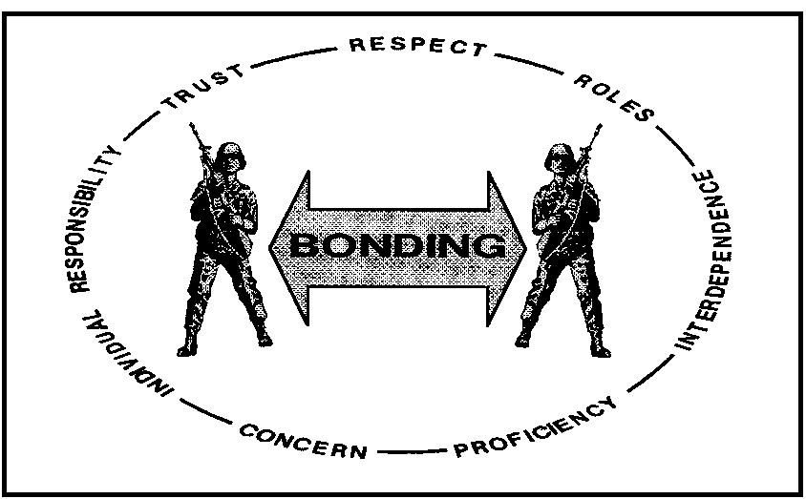

Figure 3-2, Horizontal Bonding.

-Horizontal bonding is the development of mutual trust and respect between soldiers, between leaders and between sections or platoons. A horizontal bond is the product of relationships. In companies that enjoy a high degree of bonding there is a mutual assurance that the other platoons are competent (tactically and technically), reliable, and can be trusted to perform well. Bonding of this type promotes unit confidence.

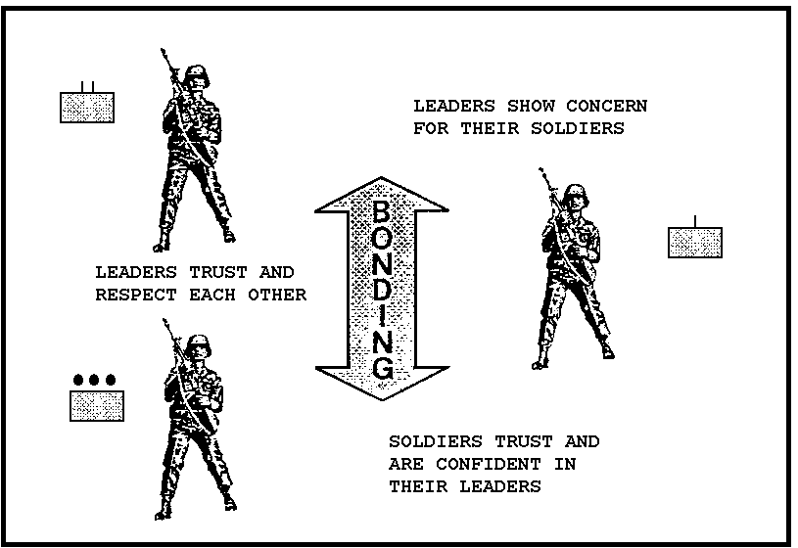

Figure 3-3, Vertical Bonding.

-Vertical bonding is the development of mutual trust and respect between soldiers and their immediate leaders. At platoon level, vertical bonding extends from the individual soldier to the platoon leader. At the company level it extends from the individual platoons to the company commander. For true vertical bonding to exist, the soldiers must view their leaders as being competent, reliable and trustworthy. Truly cohesive units display a high degree of vertical and horizontal bonding.

-The following account of a National Guard unit that was deployed to Southwest Asia during 1990-91 shows how a cohesive Reserve Component unit performed under pressure. The story is taken from the July 1991 Soldiers magazine article "Oklahoma's Finest," by SSG William H. McMichael.
Inside the cramped confines of the fire direction center, a friendly voice crackled out of the speaker putting the moment in perspective. "You're the first National Guard unit to fire a mission since Vietnam." Minutes later, a small red light on a panel in the vehicle suddenly brightened; a wordless instruction from on high. The NCO looked up, and got the message. "We're in it now, guys," he said.

The last of the 1st Battalion's equipment had arrived in Saudi Arabia from the states in mid-February. A mere four days later, the unit's Multiple Launch Rocket System (MLRS) launchers were sending a storm of "metal rain" at enemy positions.

Some in the unit were worried about what kind of confidence the other units would have in them. But they shot the first few, did pretty good, then shot in front of the Apaches. It made the unit feel worthwhile to have commanders asking for them and their support.

And that they did. Commanders requested them for tricky Joint Air Attack Team (JAAT) missions that required split-second coordination between artillery, attack helicopters, jet fighters, and close combat units as they hit enemy positions in waves. It was the first time they had ever supported JAATs.

The unit also fired artillery raids, counterbattery missions, and one battery was detached to support a British Division during the ground war. Bouncing around the theater as a Corps asset, they fired numerous missions while traveling through a total of four divisional sectors.

Part of the reason for its high level of activity was the exceptional operational readiness rate of the self-propelled loader launchers. This helped the unit snare more than its normal share of fire missions.

The original alert for mobilization didn't come as any great shock to the Guardsmen. There are only five MLRS battalions in the Army. When the unit heard that MLRS would be used they figured they would be called up. After all, the U.S. government didn't give them the MLRS to control riots.

During the first missions, the fear of counterbattery fire was on everyone's mind, but little was encountered. After that, it got to be like annual training.

The homecoming was joyous, and the unit accomplished far more than merely being deployed and surviving the war. They never missed a start point, a fire mission, or a release point.
To quote one unit member, "We've got guys that are professionals. We did what we're supposed to do. We do this on the weekends, but we proved that we could do it full time."

The Guardsmen in this Field Artillery unit enjoyed a high degree of horizontal bonding. They were confident in each other and the dedication of their maintenance and support personnel. They were also vertically bonded. This is shown by the fact that while they were in Saudi Arabia, Iraq, and Kuwait the unit was assigned to seven different higher headquarters and performed well whenever called upon. For a time one of the batteries was cross attached to a different higher headquarters. While separated from their parent battalion the battery accomplished every assigned mission. Throughout their deployment to Southwest Asia this unit accomplished every assigned combat mission; they provided fire support, moved through enemy territory, and took enemy POWs.

Their concern about the level of confidence the Active Component units would have in them was short lived. Their subsequent success indicates they are a cohesive unit. The leaders and soldiers bonded together in such a way as to develop and sustain their commitment to the unit and their resolve to accomplish the mission.

(2) Commitment is total dedication not only to the unit, its soldiers and what it represents, but to the values and goals of the nation as well. Commitment is an emotional obligation to the mission of the company and the higher headquarters. In our National Guard example, the soldiers were committed to the mission. When they received a new mission, there was a sense of commitment to the new mission, the new headquarters, and the soldiers for whom they were providing fire support. The leadership in this unit was committed to the mission and to their soldiers.

Leaders can also negatively affect the commitment of their units without realizing it. If they relate the directives of a higher headquarters to their soldiers giving the impression that the higher headquarters is unconcerned about their welfare, or unaware of what's happening in the field, they inhibit the development of commitment.

(3) Resolve is the shared determination and motivation of soldiers, leaders, and platoons to work together to accomplish the mission, and to sustain this capability over a long period of time. Resolve is the component of cohesion that keeps soldiers going, even when things aren't going well.

Did the Guardsmen in our example demonstrate resolve?
Yes, the batteries and the battalion demonstrated resolve. They were motivated and dedicated to the accomplishment of the assigned missions. They were determined to earn the confidence of the units they were supporting.

How would you have handled this situation if you were one of the battery commanders? Could you have maintained the same level of cohesion in your unit?

d. Cohesion is part of the character of a unit. If it begins to break down, leaders must be prepared to step forward and demonstrate their personal commitment and resolve. A leader's actions create the condition for cohesive growth. When you speak, make certain that you're prepared to back up your words with action. In this example, the commanders and soldiers obviously knew or sensed the importance of accomplishing the mission. Time and time again junior leaders and soldiers from this Guard unit used initiative and resolve to accomplish the mission. That is a good sign of a cohesive unit. In doing so they showed that they knew their roles and that they were dedicated to accomplishing the mission.

To reinforce his commitment and resolve to accomplish the mission, the commander must take charge in the execution of the mission. The key in this type of situation is action and reinforcement. You must act decisively and by doing so you add credibility to your headquarters. Your subordinates will understand.

Developing and maintaining a cohesive unit involves a lot on the part of the commander. If you are ever faced with a similar situation remember that there is nothing that kills commitment and resolve quicker than saying something like, "You won't believe what "they" want us to do now!" Soldiers will not perform well if they feel their leaders or the higher headquarters are not concerned about them and their welfare.

2. Earlier in this lesson we said that cohesive platoons form the foundation of cohesive units. Soldier teams and cohesive platoons are developed in three specific stages: the formation stage, the development stage, and the sustainment stage.

a. Formation stage.

Soldier teams are formed by bringing soldiers together. Normal unit situations require leaders to integrate new soldiers into already formed teams. For example, new soldiers normally are assigned to existing platoons or sections.

Cohesive companies are formed by the unit's leadership ensuring that new soldiers know what's expected of them. They explain unit values and standards. The leaders ensure that new soldiers participate in the unit's reception and orientation program. If the soldiers are married they encourage the soldier's family to participate in reception and orientation activities.

The unit's leaders may attempt to improve cohesion by designating gun crews or special teams in preparation for a training event, or a combat mission. By forming teams at the start of training, the leader tries to establish a high degree of personnel stability for an event or mission, and create a situation in which cohesion can grow.

In combat, leaders reassure new soldiers with a calm presence and pair new soldiers with experienced soldiers.

Regardless of how the team is formed, it is important to remember that all units go through fairly well-defined stages of development. While these stages follow in sequence, they have flexible boundaries and can move back and forth from one stage to another.

THE FORMATION STAGE
Reception: | Orientation:
Welcome | Unit standards-
1st impression
 | Values | Goals
 | Missions | History

b. Development stage.

During the development stage company cohesion begins as platoon cohesion emerges. Company commanders must rely on their subordinate leaders to ensure the relationships that are developed contribute to unit cohesion. Soldiers transition from new, independent members to interdependent members of the platoon and company. This transition begins to establish the interpersonal relationships between the soldiers, their peers, and their leaders. The key to success during this stage is training. All soldiers must be competent in basic soldier skills and understand their role and contribution to the mission.

Competence is required for mutual trust, respect and confidence to grow. Competent platoons, led by competent company commanders, develop the emotional tie of commitment. Companies which train as a team and focus on training for combat develop deeper levels of unit cohesion. As cohesion increases, the unit's ability to evaluate itself increases. Leaders and soldiers contribute freely and honestly to after action reviews (AARs) because the collective performance of the unit is important. Training and self-evaluation are key to success during the development stage.
THE DEVELOPMENT STAGE

Transition from:
-Independent member
Questioning
Resisting
Joining other groups

Transition to:
-Interdependent member
Mutual trust and respect
Pride through accomplishment
Team bonding and commitment

c. Sustainment stage.

The sustainment stage is characterized by accomplishing the mission through teamwork and cohesion. You'll know your unit or section has entered the sustainment stage when teams, rather than individuals, accomplish tasks and missions.

Team work is essential to the success of a Reserve Component unit given the constraints on training time. Teams must think, act and work as one. Cohesive teams that are committed to the mission achieve results quickly and efficiently. Commanders and staff officers contribute to the sustainment stage by developing challenging training that ensures the companies are capable of performing their wartime missions. Leaders keep their soldiers informed and involve everyone in the after action reviews (AAR). Individual proficiency, at all levels of the unit, ensures that the trust, respect, and confidence necessary to support a cohesive unit is maintained.

THE SUSTAINMENT STAGE

Mission accomplishment through team work

- Soldiers and leaders trust each other
- Results are achieved quickly and efficiently
- Continual self-evaluation
- Combat-focused training

d. An organization may be in all three of the stages of soldier team development simultaneously. Some platoons or sections may be in the formation stage, particularly if there is a new leader, while other platoons or sections may be in the development or sustainment stages. Commanders must rely on their subordinate leaders to ensure that the right things happen at the right time within the platoons. Commanders establish the policies and procedures necessary to support the formation, development and sustainment of cohesive soldier teams.
Think about our Desert Storm example again. What actions do you think the battery commanders took that helped to develop unit cohesion? How will you and your subordinate leaders begin to develop a cohesive unit?

3. The final fundamental of unit cohesion is the factor areas of unit cohesion. There are seven factor areas of unit cohesion that are important to you as a commander or staff officer. They are:

-Leadership
-Group (unit) characteristics
-Individuals in the unit
-Unit socialization
-Unit and individual goals and objectives
-Unit activities
-Unit identification and history

The factor areas are important because the actions that affect unit cohesion may be cataloged under one or more of these seven factor areas. Think back to our discussion of when it felt good to be part of your last unit. Although it's easy to recognize when a unit is either cohesive or not cohesive, it's often difficult to identify or isolate the cause of that condition. Leaders can begin to identify and understand the events or circumstances that affect unit cohesion when they view them in terms of the factor areas of unit cohesion.

a. Leadership. The critical factor in the development of a cohesive unit is leadership. Leaders create the climate for the growth of unit cohesion. They do this in three ways: by demonstrating their professional competence, communicating effectively with their soldiers, and trusting their subordinates.

Professional competence. Leaders who have a wealth of knowledge about such things as field craft, how to keep equipment working, how to use supporting weapons, how to pass inspections, and how to train soldiers for combat, quickly earn the trust and respect of their soldiers. Competent officers and noncommissioned officers are masters of their profession.

Communication. The second way leaders create a climate for cohesive growth is through effective communication. They consider in advance the effects of their words and actions. Good communicators don't assume that their intentions are apparent to their subordinates. They make sure their behavior communicates the same messages as their words and that the messages are in line with their intentions.

Trust. The third way leaders create a cohesive climate is by trusting their soldiers and being committed to their welfare. Trust is essential to the development of vertical bonding and commitment. Soldiers who are trusted by their leaders exercise initiative and take responsibility for their actions. It is impossible for a leader to gain the respect of his soldiers if he does not trust and respect them.

Leaders create the climate for cohesive growth by--

-Demonstrating professional competence.
-Communicating clearly.
-Establishing a climate of trust.
-Delegating responsibility to subordinates.

b. Group (unit) characteristics.

In a company each platoon, squad or section is unique and each has its own characteristics. Additionally, your soldiers are members of other groups such as family, clubs, sports teams, and churches. The cliques that develop in a unit also are groups. It is through interaction with other group members that individuals satisfy personal needs and interests. Each of the groups your soldiers belong to has the potential to influence unit cohesion.

Company commanders and staff officers create the climate for cohesive growth within groups by--

-Encouraging the growth of groups along organizational lines. (Platoon, squad, section) Ensuring each of these groups has sufficient members to accomplish the mission.
-Reinforcing group behavior that has a positive influence on the unit.
-Building group pride and linking that pride to the unit mission.
-Creating conditions that require group interaction.

Unfortunately, from time to time, a group's behavior may have a negative impact on unit cohesion.

If a group begins to set itself apart from the rest of the unit and detracts from cohesion, what can you do to develop a more cohesive unit?

Remember that horizontal bonding occurs between soldiers in platoons. If the group is organized along organizational lines, (e.g., squad or platoon) talk to the formal leaders of the group. They may not realize the impact the group is having on the unit. Direct their efforts toward unit missions and establish conditions that require group interaction. If the group is not organized along organizational lines (e.g., clique, team, or club) your task is more difficult. First, identify the informal leaders of the group. Counsel these soldiers. Explain the effect of their actions on the unit. Explain what you expect and how the informal group can contribute to unit cohesion. Then listen and consider what they have to say. If this doesn't work, you may need to use a more formal form of counseling and possibly disciplinary action if appropriate. When you do this, ensure you recognize and reinforce the behavior of other groups that contribute to unit cohesion. In an extreme case, you may need to reorganize your unit.

c. Individuals in the unit.

A commander's attention must be dual focused. It must be directed toward the development of the unit as a whole and toward the development of each soldier. Leaders must respond to the personal interests and needs of their soldiers. Soldiers who believe that they are valuable, contributing members of the unit become more cohesive than those who do not.

Leaders create a climate in which individuals develop a sense of self-worth and cohesion by--

-Establishing buddy teams.
-Making the effort to know each of the soldiers in the unit.
-Ensuring each soldier is able to perform his job to standard.
-Encouraging and recognizing individual initiative.

Remember that bonding is the development of an interpersonal relationship between soldiers and between soldiers and their leaders. By getting to know each of your soldiers you begin to establish the interpersonal relationship necessary for the development of a vertical bond. When your subordinate leaders establish buddy teams, ensure that each soldier is able to perform to standard. Recognize individual initiative and actions that contribute to unit cohesion.

d. Unit socialization.

Socialization is the process by which a new soldier acquires the skills, knowledge and attitudes unique to his new unit and is accepted into the unit. Socialization takes place during the formation stage of soldier team development and whenever new soldiers or new leaders join the unit. If you don't establish a socialization program in your unit, the soldiers in your unit will! In Almost every unit there is a group that, if given a chance, will detract from unit cohesion if you don't have an effective socialization program.

Leaders create the climate for the growth of cohesion by--

-Establishing a good reception and orientation program.
-Setting and maintaining high standards.
-Reinforcing attitudes and actions that support the professional Army ethic.

If your unit's socialization process is effective, your soldiers will start out on the right foot. Communicate unit standards clearly; ensure the new soldier understands them. Set the example for values and ethics. Your actions in this area will speak much louder than words. The tone that you and your subordinate leaders establish will leave a lasting impression on the new soldier.

e. Unit and individual goals and objectives.

One of the most important factor areas of unit cohesion is the integration of unit and individual goals and objectives. Once soldiers see the relationship between achieving unit goals and the realization of their goals they become more involved in the unit. They begin to establish the resolve necessary to accomplish difficult missions. Although it's possible to achieve unit goals without the soldiers internalizing them, the soldiers won't have the perseverance to sustain that level of achievement over a long period of time. Think back to our Desert Storm example. In that case, the soldiers were concerned that other units might not have confidence in their ability to accomplish the mission. These Guardsmen made the mission of the higher headquarters "their" mission. Leaders create the climate for the growth of cohesion by--

-Ensuring unit goals are clear and understood by the soldiers.
-Keeping unit goals battle focused.
-Involving subordinates in goal setting when appropriate.
-Knowing their subordinates' personal goals.

As a commander, you won't know all of your subordinates' goals. However, your platoon leaders and sergeants should know most of your soldiers' goals. Soldiers have personal goals that are very important to them. Some of their goals may involve promotion, job assignments and additional schooling. If the goals are consistent with unit objectives, then achieving these goals will contribute to the effectiveness of the unit.

f. Unit activities.

Unit activities include everything that a unit does. Far too often leaders associate unit activities with events such as company parties and unit organization days.

Field training exercises, crew qualification exercises and command inspections also are unit activities. The most important unit activity is training. It doesn't matter when or where the training takes place, weekend drill, annual training or deployed half way around the world. Leaders create the climate for the growth of cohesion by--

-Conducting challenging, realistic training.
-Selecting unit events carefully.
-Involving family members when appropriate.
-Using competition constructively.

When it comes to training, the greater the level of excitement and realism, the more it contributes to unit cohesion. If your training program puts people to sleep how can it enhance cohesion? Don't schedule unit trips and outings just to have them. Make sure the event is something your soldiers want to do.

Family members can be a big part of your unit. If they have a positive feeling about the unit, your soldiers will be more satisfied. Include families in activities when it's appropriate. For example, set up a part of a weekend drill so that the soldiers' families can observe the unit during training. Include the unit's internal support activities such as supply and maintenance. Have someone explain what's happening while the families observe the training. Soldiers have a lot of pride in what they do but their families seldom see what the soldiers really do.

Competitive events in the unit should never detract from cohesion. Design recognition awards so that they recognize exceptional performance. There is nothing to be gained by designating a best squad if all of the squads have met the standard. Competing against a standard, rather than each other, creates the condition for the growth of cohesion.

g. Unit identification and history. What was the motto of your last unit? Did you say it with pride or was it more of an annoyance?

There isn't a unit in the Army that doesn't have a proud history. A cohesive unit draws strength from the achievements of those who have previously served in the unit. Create a climate for the growth of cohesion by--
-Including unit history in the orientation program.
-Developing a sense of company history.
-Making unit mottos mean something and using them correctly and with pride.

When new soldiers arrive, introduce them to your unit's history. Present your unit's standards, mission and goals as part of a continuing tradition. Make it a personal goal to develop a company history. A scrapbook is a simple way to do this. Get your platoons and sections involved. Update it after unit activities. Use humor, snap shots, anything that captures the spirit of the unit. Don't allow unit mottos to become trite or sarcastic. If this happens, it's evidence that your soldiers don't understand. Ensure that your subordinate leaders understand and use the motto correctly.

4. Review. It may appear that all of this is common sense, to some extent that's true. However, it's the simple things that are often overlooked. Unit cohesion is the integration of cohesive platoons, coupled with commitment and resolve. Each leader must understand his or her responsibility and role in developing and sustaining unit cohesion.

a. Cohesion is defined as the bonding together of soldiers and their leaders in such a way as to develop and sustain their commitment to their unit and their resolve to accomplish the mission. The key words in the definition are bonding, commitment and resolve.

Cohesion at the company level involves the bonding of key unit leaders and platoons, developing platoons that are committed to the company mission and that possess the resolve to execute that mission. From a soldier's perspective cohesion is the feeling of belonging to a unit that consists of soldiers and leaders who trust each other, respect each other, are confident in each others' abilities, and who can be relied upon to make the sacrifices necessary for the good of the unit. Leaders create the conditions that allow unit cohesion to emerge.

b. There are three stages of soldier team development, the formation stage, development stage and, the sustainment stage. While these stages generally follow in sequence they have flexible boundaries and many things can cause a unit to move back and forth from one stage to another. As squads and platoons move through the stages of development, the level of company cohesion should increase.

c. There are seven factor areas of unit cohesion that we use to categorize unit and individual actions. They are:

- Leadership.
- Group (unit) characteristics.
- Individuals in the unit.
- Unit socialization.
- Unit and individual objectives and goals.
- Unit activities.
- Unit identification and history.

PART B

ASSESSING THE COHESIVENESS OF AN ORGANIZATION

Unfortunately there isn't a "litmus test" for unit cohesion. We've talked about the concept of cohesion, the stages of soldier team development and how these stages relate to cohesion, and we've looked at the factor areas of unit cohesion, but we haven't talked about how a commander assesses or evaluates unit cohesion. How would YOU determine the level of cohesion in a unit?

1. To determine the level of cohesion in a unit, leaders frequently look for indicators. Indicators such as:

- How many people attend a company party?
- Do the soldiers in the unit trust each other?
- Are the indiscipline and AWOL rates low?
- Do squads and platoons accomplish the mission as a team?
- Do the soldiers demonstrate pride in the unit?

Indicators such as these provide us a "gut feeling" for the level of cohesion in the unit. Based on this feeling we might say, "Yes, my unit is cohesive." "No, my unit is not cohesive." Or, "My unit is somewhat cohesive." The last answer is frequently the honest answer. This type of an evaluation rarely provides the leader with an accurate picture of the level of cohesion and it doesn't provide any information regarding the cause of a lack of cohesion. Assessing or evaluating unit cohesion involves more than simply forming an impression. One method of assessing unit cohesion involves three steps:

Step 1 - Recognizing (observing) and recording subordinate unit and individual performance.

Step 2 - Classifying the performance in terms of the factor areas of unit cohesion.

Step 3 - Evaluating or rating the actions or performance in terms of their contribution to unit cohesion.

2. Assessing unit cohesion.

a. Step 1 in the assessment or evaluation of unit cohesion is recognizing, or observing, and recording subordinate unit and individual performance. Subordinates in this step involve more than just your key subordinate leaders. It includes the soldiers, team leaders, and squad leaders as well.

When you make your observations look at:

-Key leader actions. How do the leaders interact with the soldiers?

-Soldier reactions. How do the soldiers react to the directions of their leaders?

-Leader performance. Are the leaders competent? Do they serve as positive role models? Are they involved in the completion of the mission?

-Soldier performance. Are your soldiers competent? Do they exercise initiative and ensure the task or mission is accomplished to standard?

-Unit policies. How do unit policies affect the way soldiers and leaders perform their jobs?

Another important aspect of the assessment or evaluation step is obtaining input from others. Talk to:

-Your key leaders, (e.g., XO, 1SG, platoon leaders and platoon sergeants). What are their perceptions of cohesion in the unit?

-Your soldiers. What are their perceptions of cohesion in the unit?

-Fellow commanders. How would they characterize your unit? This is especially important if your unit task organizes for combat. How cohesive are the platoons or "slices" that become part of another commander's combat team?

-Your battalion commander and command sergeant major. What are their observations and perceptions of cohesion in your unit?

The final aspect of your unit that you'll want to evaluate is characterized by an old expression, "the proof is in the pudding." How does your unit go about accomplishing its daily mission? Look at:

-Unit formations. When you look at a platoon do you see a team or a collection of individuals? When you step back and look at the company do you see a company with a common purpose and direction, or three to four separate platoons? Are your subordinate leaders involved in the formation?

-Training. Are your soldiers going through the motions, or is quality training being conducted? Is the training battle focused and conducted by complete platoons or sections? Is your unit training on the right tasks, at the right level? Can your soldiers, at the end of the day say, "I'm better prepared for combat because of what I did today?" When you conduct AARs, do your soldiers and subordinate leaders participate openly and honestly?

-Climate. What is the general climate of your unit? How do soldiers talk to each other? To their leaders? How do the leaders talk to each other and their subordinates? Do soldiers help each other? Is the mood of the unit open and friendly or cold and impersonal?

Remember, when you make these observations, don't attempt to validate a preconceived impression. Your observations should reflect exactly what you see and hear. How much time should you spend making and recording these observations? That will depend on the situation. Why are you concerned about the level of cohesion in your unit? Something has caused your concern. You should be able to make and record enough observations during a weekend drill to obtain an accurate picture of your unit.

b. Step 2 is the classification of the unit's performance or actions in terms of the factor areas of unit cohesion. The factors areas are important because nearly everything that occurs in a unit can be categorized under one of these areas. From Part A, page 10, here they are again:

-Leadership
-Group (unit) characteristics
-Individuals in the unit
-Unit socialization
-Unit and individual goals and objectives
-Unit activities
-Unit identification and history

These factor areas also assist you in identifying both the cause and possible remedies for the problem areas. Let's look at two quick examples of how to classify actions or observations. Read the following situations and answer the question at the end.
Situation 1:

2d Platoon designed a platoon coat of arms. The platoon had T-shirts made and the entire platoon wore the T-shirts for PT.

Question - How would you classify this observation using the factor areas of unit cohesion?

Answer - This observation could be classified under either group (unit) characteristics or unit identification and history.

Situation 2:

1SG Smith assigned PVT Jones to SSG Blake's squad. He told PVT Jones that SSG Blake is enrolled in off duty college courses and since PVT Jones recently quit college and joined the Army because of a lack of money, SSG Blake could assist him in lining up inservice college benefits.

Question - How would you classify this observation using the factor areas of unit cohesion?

Answer - This observation also can be classified under either unit and individual goals and objectives or unit socialization.

These are simple examples; however, they illustrate how an observation can be classified under the factor areas of unit cohesion. When you classify or categorize an observation, try to select one factor area. The situation in which you make the observation frequently helps in this determination. It is also possible that some of your observations won't fit under any of the factor areas. For example if, while observing your unit, you make an observation that " SSG White marched his squad to the dining facility," you might find it difficult to classify the observation. That is because squad leaders routinely march their squads to the dining facility, therefore, the observation isn't significant. As you classify your observations, discard those that are not significant.

c. Step 3 is evaluating or rating the actions or performance in terms of their contribution to unit cohesion. As you classify your observations, you probably will notice that some of the observations are positive in nature while others are negative. This is a common occurrence.

3. Review. A method of assessing unit cohesion involves three steps:

-Recognizing and recording subordinate performance.

-Classifying the performance in terms of the factors of unit cohesion.

-Evaluating or rating the actions or performance in terms of their contribution to unit cohesion.

a. Recognizing and recording subordinate performance. There are a number of means available to the commander to recognize (observe) and record subordinate performance. They include:

-Personal observation.
-Input from key leaders within the unit.
-Input from subordinates.
-Input from fellow commanders.
-Input from your battalion commander and command sergeant major.

Each of these sources provide the commander with a great deal of insight into his organization.

b. Classifying the performance in terms of the factor areas of unit cohesion. By classifying or rating unit and soldier performance, the commander is able to see how the routine, day-to-day actions of his soldiers and subordinate leaders affect unit cohesion. The assessment process assists you in the identification of the factor areas that are in the greatest need of improvement.

c. Evaluating or rating the actions or performance in terms of their contribution to unit cohesion. After classifying and rating each significant observation, you have an accurate picture of how each factor area either contributes to or detracts from unit cohesion. You also can identify trends or areas that are either strong or weak. Use this knowledge to focus your efforts and improve or enhance unit cohesion in those areas that need improvement.
PART C

HOW TO USE THE FACTOR AREAS OF UNIT
COHESION TO IMPROVE COHESION

1. The development of a plan to improve unit cohesion also involves a three step process, very similar to the one used to assess the unit.

STEP 1-Establish clear goals and objectives for each factor area which you want to influence.

STEP 2-Brief your subordinate leaders on your findings, your goals and objectives, seek their input, and involve them in the development and implementation of the plan to improve unit cohesion.

STEP 3-Conduct an after action review of the execution of your plan and make adjustments as necessary.

2. Now let's look at each step in detail.

STEP 1 involves the development of clear goals and objectives for each factor area which you want to influence.

What goals and objectives would you set to improve the weak factor areas in your unit? Are the goals reasonable? Are they linked to a factor area that needs improvement? How will you measure achievement of the goal? Write out your goals.

STEP 2 calls for briefing and involving your subordinate leaders in the development of the plan. This is critical to the success of your effort. Remember that leaders create the climate for the growth of cohesion. Your platoon leaders, platoon sergeants, and squad leaders are the individuals who will actually implement the steps necessary to achieve your goals.

The plan which you and your subordinate leaders develop should be simple and straightforward. It should focus on leader behavior and performance. For example, one of your observations may have been that your soldiers in 1st Platoon frequently fail to perform to standard. While talking to the soldiers from the 1st Platoon, you made another observation, as they said, "We're frustrated because our standards always seem to change. Our sergeants tell us one thing and we're expected to do something else." To correct this situation your plan might look something like this:

GOAL: Ensure general unit standards and specific performance standards are understood and achieved by all unit members. The achievement of this goal will be measured by impromptu discussions with the soldiers by key leaders and by observing soldier performance. The factor areas which relate to this observation include: leadership, group characteristics, and unit socialization.

LEADER ACTIONS: The commander and 1SG will brief all newly assigned personnel on general unit standards. Platoon leaders and platoon sergeants will communicate platoon standards and reinforce the unit standards to all newly assigned personnel. Key unit leaders will establish specific standards of performance for all training events. These key leaders will communicate the established performance standards to the soldiers prior to the training event. Subordinate leaders will supervise individual soldier performance, provide on the spot assistance and conduct AARs at the conclusion of each training activity.

What your subordinate leaders may not realize is that, as they work to increase the level of cohesion in the unit and their platoons, they'll be relying on each other for support. Because of this, the level of horizontal bonding between subordinate leaders should also increase. If your plan is properly executed the entire unit becomes healthier. Admittedly, this is the best case and the result of executing your plan may not always match your expectations. This fact of life makes the final step necessary.

In STEP 3 you must conduct an after action review of the execution of your plan and make adjustments as necessary. By using this process you are actually training your subordinate leaders in the development of a cohesive unit. Treat this process as a training activity and the actions you initiate should become embedded in the character of the unit.

3. Assessing or evaluating the cohesiveness of a unit and developing a plan which improves unit cohesion is a difficult leader task. It's something you may think that you will not have time for, or be able to do, right after taking command. But if you don't you may find yourself reaching the conclusion that things just aren't coming together the way they should. The development of a cohesive unit is linked very closely to creating or establishing a positive command climate. Command climate which was addressed in lesson two involved a more formalized assessment or evaluation process. Because of this linkage, if you discover that your unit is not as cohesive as you thought it was, you would be well advised to assess both your unit's command climate and level of cohesion at the same time. The Unit Climate Profile (UCP), which is the subject of DA PAM 600-69, gives you the soldiers' perspective of the climate in a unit. If you combine the information you gain through the use of the UCP with your own observations you will be much better prepared to improve unit cohesion in your organization.

4. Review.

a. The development and implementation of a plan to improve or enhance unit cohesion involves 3 steps:

-Establish clear goals and objectives for each factor which you want to influence.

-Brief your subordinate leaders on your findings, your goals and objectives, seek their input, and involve them in the development and implementation of the plan to improve unit cohesion.

-Conduct an after action review of your plan and make adjustments as necessary.

b. Leaders create the conditions in which cohesion is developed. This process allows the commander to determine the needs of the unit and, with the assistance of his subordinate leaders, develop a plan to improve unit cohesion. The after action reviews are necessary to ensure the desired development is achieved. By conducting AARs your soldiers will associate the actions involved in developing a cohesive unit with training. Remember, training is the key element in the development of cohesive soldier teams.

c. The Practice Exercise that follows gives you an opportunity to apply your knowledge of unit cohesion and develop a plan to build a cohesive unit.

